TASK REPORT

Food Delivery App Homepage Design
UI/UX Design using Figma

1. Objective
To design a modern food-delivery app homepage inspired by familiar food-ordering experiences such as Zomato and Swiggy. The layout helps users find food quickly, discover offers, review nearby restaurants, and navigate with minimal effort.

2. Tool and Reference
Design tool: Figma
Reference output: the supplied mobile homepage screenshot, included below as the visual output/reference for this task.

3. Homepage Layout and Main Sections
- Header and delivery location: Shows the delivery address, profile avatar, and a prominent search field for restaurants, dishes, or cuisines.
- Quick navigation chips: Provides shortcuts for Delivery, Dining Out, Offers, Healthy, and Pocket Friendly.
- Food categories: Displays circular category images and labels such as Biryani, Pizza, Burger, Chinese, North Indian, and Desserts.
- Featured promotional banner: Highlights a first-order offer with a bold discount message, free-delivery text, and an Order Now call to action.
- Restaurant listing: Presents a restaurant card with a food image, offer badge, estimated delivery time, restaurant name, rating, cuisine, price, and delivery information.
- Footer / bottom navigation: Provides persistent access to Delivery, Explore, Orders, and Saved sections using simple icons and labels.

4. Visual Design Choices
- Color palette: red is used for primary actions, active navigation, and offer highlights; white and light grey keep the interface clean; dark text maintains readability.
- Typography: bold headings establish hierarchy, while smaller supporting labels communicate cuisine, price, and delivery details.
- Rounded components: search, category shortcuts, promotional banner, and restaurant cards use rounded corners for a friendly mobile-app feel.
- Content hierarchy: the screen moves from location and search to categories, promotion, and nearby restaurants.
- Mobile-first layout: content is arranged vertically for scrolling on a phone, with bottom navigation kept separate from the main feed.

5. Steps to Recreate in Figma
- Create a new Figma design file and add a mobile frame (for example, approximately 390 × 844 px; adjust to the reference screenshot proportions).
- Build the header with delivery location, profile image, and a rounded search bar.
- Add pill-shaped navigation chips and a row of circular food-category thumbnails with labels.
- Create the promotional banner using a pale warm background, bold discount text, supporting copy, a red call-to-action button, and food imagery.
- Design restaurant cards with a wide food image, offer and delivery-time overlays, restaurant details, rating, price, and delivery information.
- Add a bottom navigation area with four evenly spaced icons and labels.
- Use Auto Layout, consistent spacing, reusable components, and text/color styles to keep the design aligned and easy to update.
- Compare the Figma frame with the supplied screenshot and refine spacing, contrast, alignment, and text sizes.

6. Output Screenshot
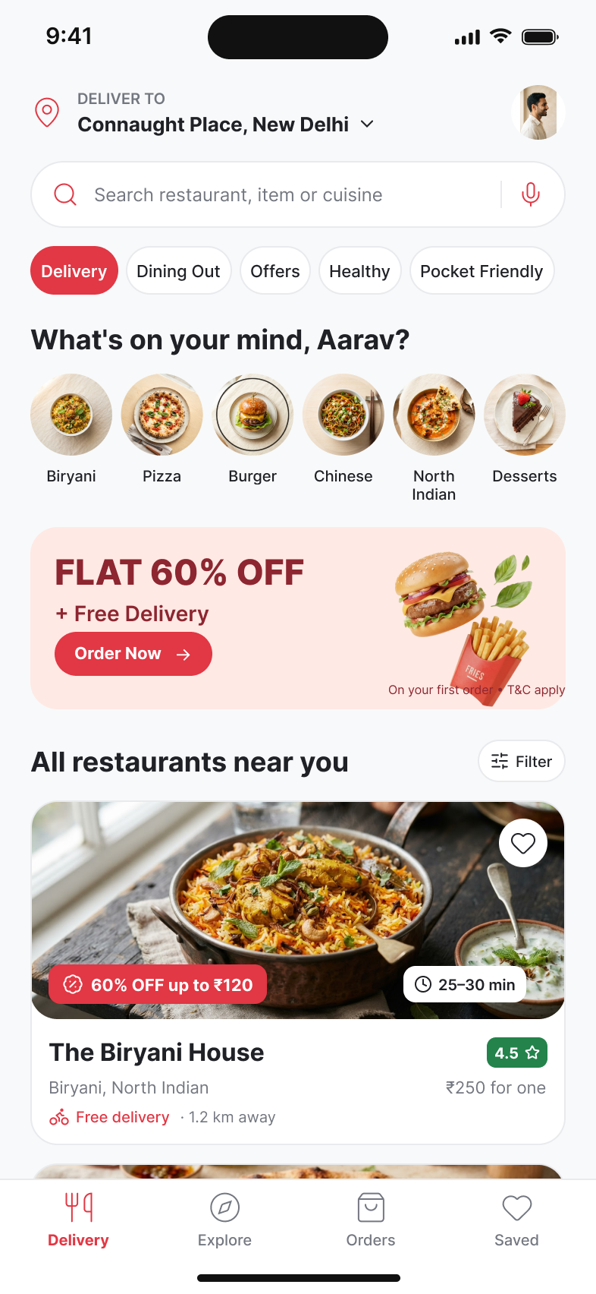
The supplied screenshot is placed below as the task output/reference. It illustrates the intended homepage structure and visual styling.

7. Result and Conclusion
The homepage organizes key food-ordering actions into a clear mobile experience: confirm location, search, browse categories, view a promotion, and inspect restaurant details. The supplied screenshot serves as the visual output for this report. For a complete submission, recreate the screen in Figma and capture an export of the actual Figma frame.

